HALF ADDER USING NAND-BASED LOGIC GATES

1. Objective
To design and simulate a half adder using custom XOR and AND gate modules implemented from NAND gates in Verilog HDL, and verify its functionality through behavioral simulation and FPGA synthesis in Xilinx Vivado.

2. Theory
A half adder is a combinational logic circuit that adds two single-bit binary inputs, A and B, to generate two outputs: Sum (S) and Carry (C).
The Sum output is generated using the custom XOR gate module, while the Carry output is generated using the custom AND gate module. Both modules reuse the NAND-based logic gates developed previously.
During FPGA synthesis, Vivado optimizes the hierarchical design into LUT-based logic. The synthesized circuit uses separate LUTs for the Sum and Carry outputs.

3. Boolean Equations
Sum:
S = A ⊕ B
Carry:
C = A · B

4. Truth Table — Cell Properties

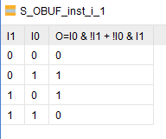

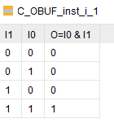

5. Simulation Waveform

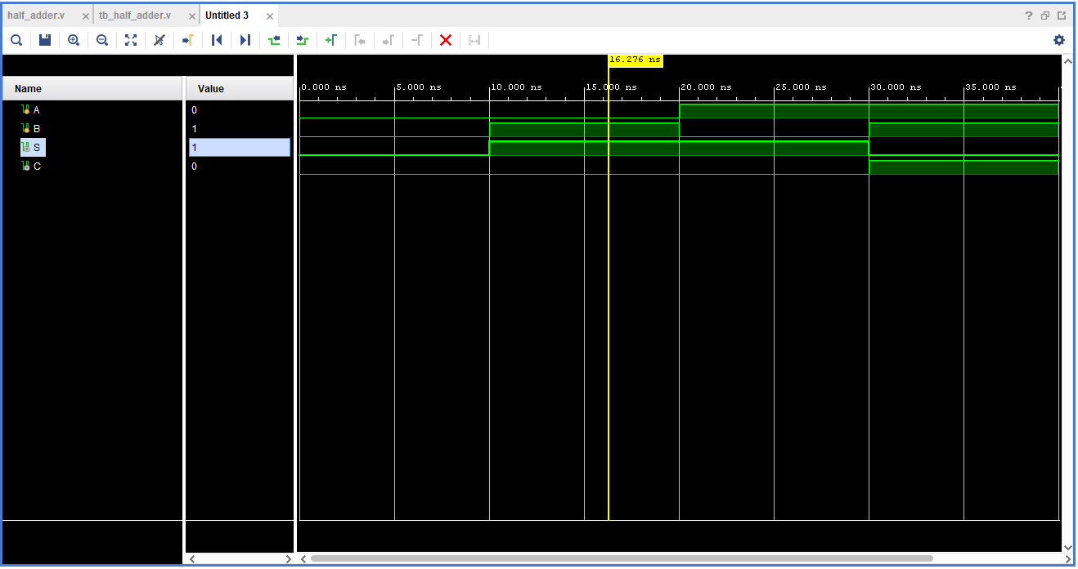

6. Synthesized Schematic

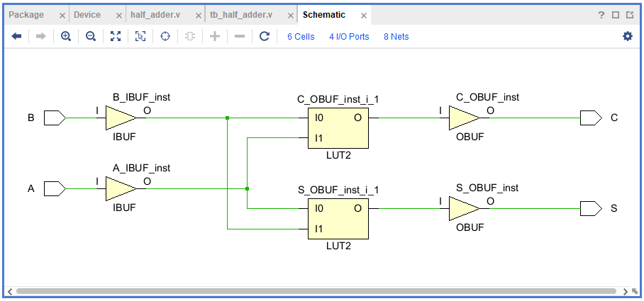

7. LUT INIT Value
Carry LUT — C_OBUF_inst_i_1
Observed INIT: 4'h8
Binary value: 1000
This implements the AND function, producing 1 only when both inputs are 1.
Sum LUT — S_OBUF_inst_i_1
Observed INIT: 4'h6
Binary value: 0110
This implements the XOR function, producing 1 when the two inputs are different.

FULL ADDER USING NAND-BASED LOGIC GATES

1. Objective
To design and simulate a full adder using custom half-adder and OR gate modules implemented from NAND-based logic gates, and verify its functionality through behavioral simulation and FPGA synthesis in Xilinx Vivado.

2. Theory
A full adder is a combinational logic circuit that adds three single-bit binary inputs: A, B, and the carry-in (Cin). It generates two outputs: Sum (S) and Carry-out (Cout).
The design uses two instances of the previously developed half-adder module. The first half adder adds A and B, while the second adds the intermediate sum to Cin. An OR gate combines the two intermediate carry outputs to generate Cout.
During FPGA synthesis, Vivado optimizes the hierarchical logic into LUT-based logic. The synthesized design contains separate LUTs for the Sum and Carry-out functions.

3. Boolean Equations
Sum:
S = A ⊕ B ⊕ Cin
Carry-out:
Cout = (A · B) + (Cin · (A ⊕ B))

4. Truth Table — Cell Properties

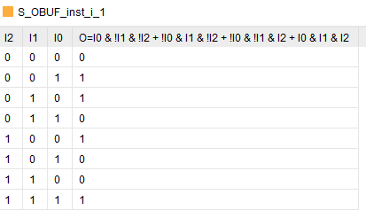

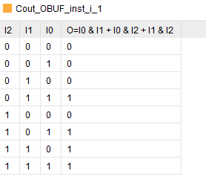

5. Simulation Waveform

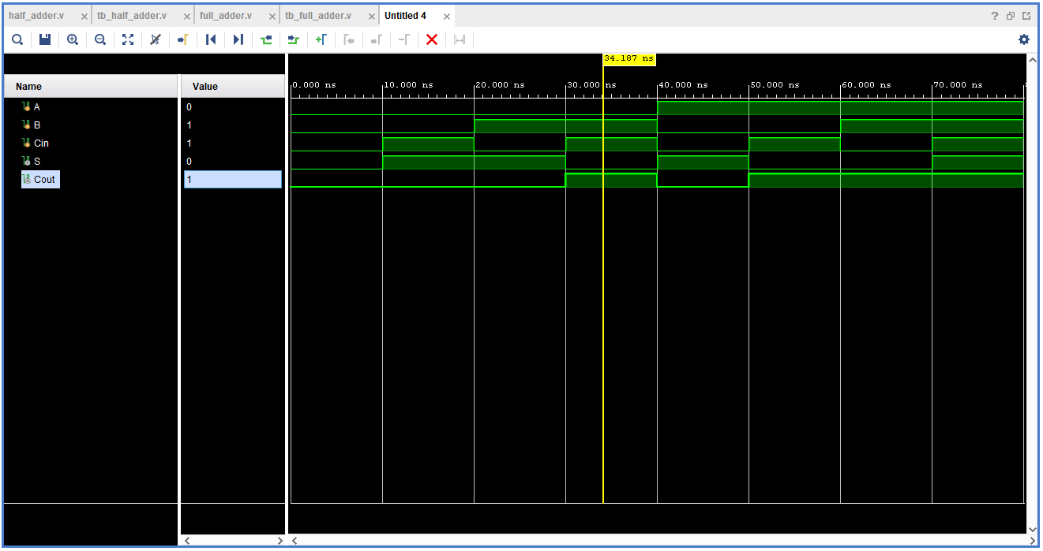6. Synthesized Schematic
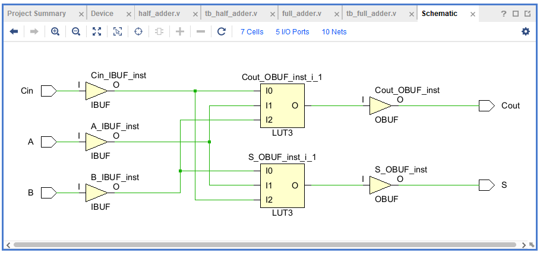.

7. LUT INIT Value
Carry-out LUT — Cout_OBUF_inst_i_1
Observed INIT: 8'hE8
Binary value: 11101000
This LUT implements the full-adder Carry-out function.
Sum LUT — S_OBUF_inst_i_1
Observed INIT: 8'h96
Binary value: 10010110
This LUT implements the full-adder Sum function, producing 1 when an odd number of the three inputs are 1.

4-BIT RIPPLE-CARRY ADDER USING NAND-BASED LOGIC GATES

1. Objective
To design and simulate a 4-bit ripple-carry adder (RCA) by connecting four instances of the previously developed full-adder module, implemented using NAND-based logic gates. The design is verified through behavioral simulation and FPGA synthesis in Xilinx Vivado.

2. Theory
A 4-bit ripple-carry adder is a combinational logic circuit that adds two 4-bit binary numbers, A and B, along with an initial carry-in (Cin). It produces a 4-bit sum (Sum) and a final carry-out (Cout), giving a 5-bit result.
The design consists of four full-adder instances connected in cascade. The first full adder processes the least significant bits, A[0] and B[0], along with Cin. Its carry output is passed to the second full adder. Similarly, the carry propagates through the third and fourth full adders, producing the final carry-out.
This sequential propagation of carry signals gives the circuit its name, ripple-carry adder. Although its architecture is simple and modular, the carry propagation delay increases with the number of bits.
During FPGA synthesis, Vivado optimizes the hierarchical logic into LUT-based logic. Therefore, the synthesized schematic may not preserve the original four-full-adder structure exactly.
The design was verified using a self-checking testbench that tested all 512 possible combinations of the two 4-bit inputs and the carry-in. All 512 test cases passed successfully.
3. Boolean Equations
For each bit position (i), where (i = 0, 1, 2, 3):
Propagate:
(Pᵢ = Aᵢ ⊕ Bᵢ)
Generate:
(Gᵢ = Aᵢ · Bᵢ)
Sum:
(Sumᵢ = Pᵢ ⊕ Cᵢ)
Carry:
(Cᵢ₊₁ = Gᵢ + (Pᵢ · Cᵢ))
Here, (C₀ = Cin), and the final carry (C₄ = Cout).
Full-Adder Stage Mapping:
The 4-bit ripple-carry adder consists of four full-adder stages connected in cascade.
Stage 0 — Least Significant Bit (LSB):
Inputs: A₀, B₀, C₀ (Cin)
Outputs: Sum₀, C₁
Stage 1:
Inputs: A₁, B₁, C₁
Outputs: Sum₁, C₂
Stage 2:
Inputs: A₂, B₂, C₂
Outputs: Sum₂, C₃
Stage 3 — Most Significant Bit (MSB):
Inputs: A₃, B₃, C₃
Outputs: Sum₃, C₄ (Cout)
The carry output of each full-adder stage is connected to the carry input of the next stage. This sequential carry propagation is the defining characteristic of a ripple-carry adder.
Carry Equations for the Four Stages:
C₁ = G₀ + (P₀ · C₀)
C₂ = G₁ + (P₁ · C₁)
C₃ = G₂ + (P₂ · C₂)
C₄ = G₃ + (P₃ · C₃)
The complete result is represented as:
({Cout, Sum[3:0]} = A + B + Cin)

4. TCL Console Output After Simulation
The behavioral simulation was completed successfully in Xilinx Vivado.
Observed output:
PASS: All 512 test cases passed!
$finish called at time : 5120 ns
This confirms that the RCA produced the correct result for every possible combination of A, B, and Cin.

5. Simulation Waveform
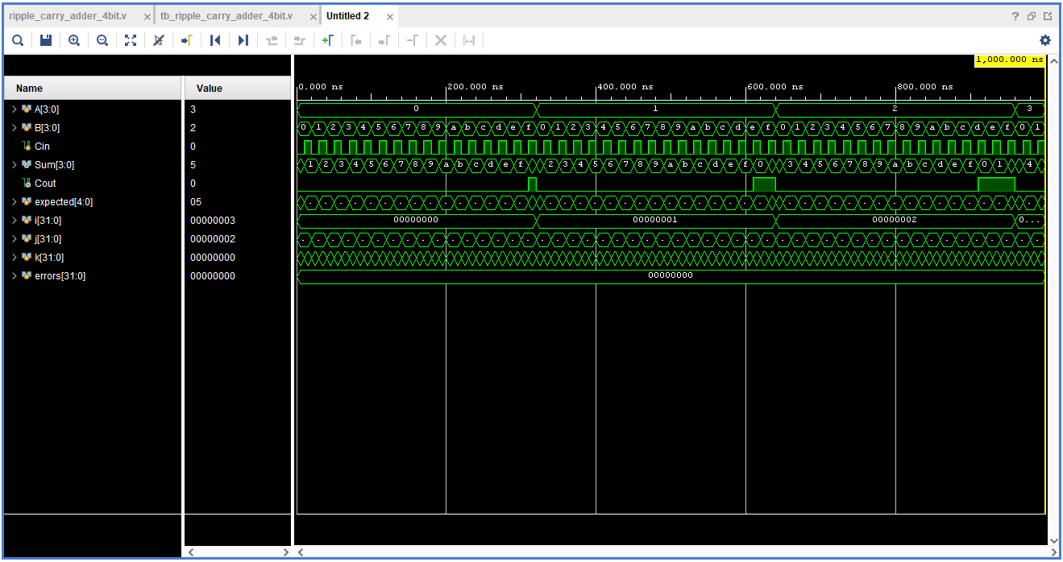The waveform demonstrates the input combinations, the corresponding 4-bit sum, and the carry-out signal during simulation.

6. Synthesized Schematic

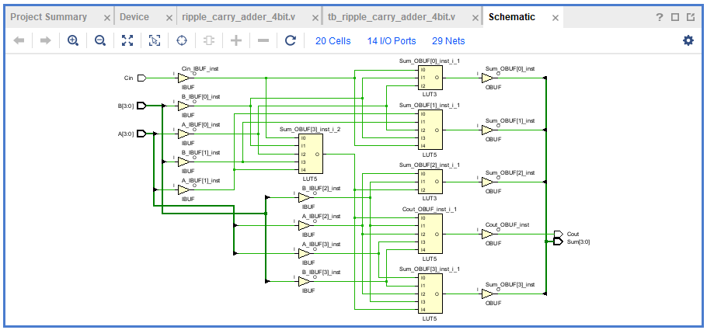7. LUT INIT Values
The LUT INIT values were extracted directly from the synthesized design using the Vivado Tcl Console.
Output signal | LUT cell name | Observed INIT value
Carry-out | Cout_OBUF_inst_i_1 | 32'hFFE8E800
Sum bit 0 | Sum_OBUF[0]_inst_i_1 | 8'h96
Sum bit 1 | Sum_OBUF[1]_inst_i_1 | 32'h99969666
Sum bit 2 | Sum_OBUF[2]_inst_i_1 | 8'h96
Sum bit 3 | Sum_OBUF[3]_inst_i_1 | 32'h99969666
Additional Sum bit 3 logic | Sum_OBUF[3]_inst_i_2 | 32'hFFE8E800
Observations:
- 8'h96 is an 8-bit LUT truth-table pattern commonly associated with a 3-input XOR function, depending on the LUT input ordering.
- The 32-bit INIT values correspond to larger LUT truth tables and depend on how Vivado maps the logic inputs to LUT pins.
- The additional LUT associated with Sum bit 3 contributes to the synthesized output logic; it is not a separate sum bit.
- These values represent the synthesized LUT implementation and may change with the target FPGA, synthesis settings, or RTL changes.
The extracted INIT values document how Vivado implemented the optimized logic for this particular synthesis run.

4-BIT CARRY LOOKAHEAD ADDER (CLA) USING NAND-BASED LOGIC DESIGN

1. Objective
To design and simulate a 4-bit Carry Lookahead Adder (CLA) using Generate and Propagate logic, implement the carry lookahead equations in Verilog HDL, and verify the functionality through behavioral simulation and FPGA synthesis in Xilinx Vivado.

2. Theory
A Carry Lookahead Adder (CLA) is a combinational logic circuit that adds two binary numbers by calculating carry signals in advance rather than waiting for carries to propagate sequentially through each bit, as in a Ripple-Carry Adder (RCA).
The 4-bit CLA takes two 4-bit inputs, A and B, along with an initial carry-in (Cin). It produces a 4-bit Sum and a final carry-out (Cout), representing a 5-bit arithmetic result.
The design uses two intermediate signals for each bit position:
- Generate (G): Indicates whether that bit position generates a carry independently of the incoming carry.
- Propagate (P): Indicates whether the bit position can propagate an incoming carry.
For this implementation, the Generate and Propagate signals are defined as:
Gᵢ = Aᵢ · Bᵢ
Pᵢ = Aᵢ + Bᵢ
The carry signals are calculated using expanded lookahead equations, allowing the carry logic to determine the carries without relying on a serial chain of full-adder carry outputs. The sum bits are then calculated using the corresponding carry-in for each bit position.
The behavioral simulation was performed using a self-checking testbench that tested all 512 combinations of the two 4-bit inputs and Cin. All 512 test cases passed successfully.
During FPGA synthesis, Vivado optimized the RTL into LUT-based logic. The synthesized design contained 6 LUT cells, according to the Tcl Console extraction for this synthesis run.

3. Boolean Equations
Generate:
Gᵢ = Aᵢ · Bᵢ
Propagate:
Pᵢ = Aᵢ + Bᵢ
Here, (+) denotes logical OR and (·) denotes logical AND.
Carry Equations:
C₀ = Cin
C₁ = G₀ + P₀ · C₀
C₂ = G₁ + P₁ · G₀ + P₁ · P₀ · C₀
C₃ = G₂ + P₂ · G₁ + P₂ · P₁ · G₀ + P₂ · P₁ · P₀ · C₀
C₄ = G₃ + P₃ · G₂ + P₃ · P₂ · G₁ + P₃ · P₂ · P₁ · G₀ + P₃ · P₂ · P₁ · P₀ · C₀
Final Carry-out:
Cout = C₄
Sum Equations:
Sum₀ = A₀ ⊕ B₀ ⊕ C₀
Sum₁ = A₁ ⊕ B₁ ⊕ C₁
Sum₂ = A₂ ⊕ B₂ ⊕ C₂
Sum₃ = A₃ ⊕ B₃ ⊕ C₃
Final Result:
Result = {Cout, Sum₃, Sum₂, Sum₁, Sum₀} = A + B + Cin

4. TCL Console Output After Simulation
The behavioral simulation completed successfully in Xilinx Vivado.
Observed output:
PASS: All 512 CLA test cases passed!
This confirms that the CLA produced the correct 5-bit arithmetic result for all possible combinations of A, B, and Cin.

5. Simulation Waveform
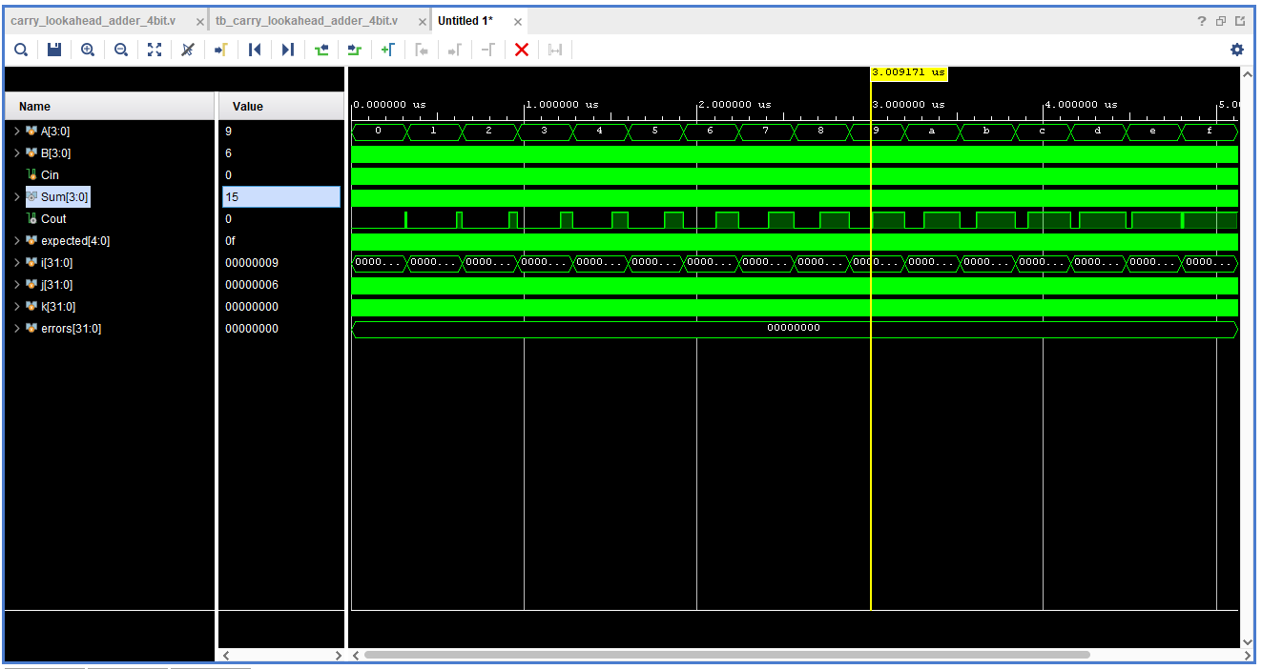The waveform displays the input operands A and B, the initial carry-in Cin, the resulting 4-bit Sum, the final carry-out Cout, and the expected result generated by the testbench.

6. Synthesized Schematic
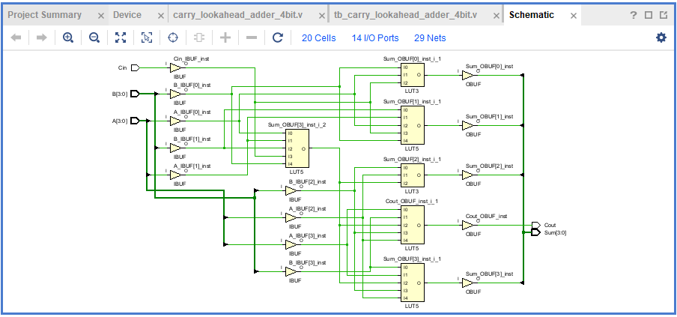
The schematic shows the LUT-based implementation generated by Vivado, including the input and output buffers and the optimized combinational logic.
Observed synthesis summary:
- Total cells: 20
- I/O ports: 14
- Nets: 29
- LUT cells: 6
These values correspond to the current synthesized design and may vary with the target FPGA, synthesis settings, or RTL modifications.

7. LUT INIT Values
The LUT INIT values were extracted from the synthesized design using the Vivado Tcl Console.
Output signal | LUT cell name | Observed INIT value
Carry-out | Cout_OBUF_inst_i_1 | 32'hEEE8E888
Sum bit 0 | Sum_OBUF[0]_inst_i_1 | 8'h96
Sum bit 1 | Sum_OBUF[1]_inst_i_1 | 32'h99969666
Sum bit 2 | Sum_OBUF[2]_inst_i_1 | 8'h96
Sum bit 3 | Sum_OBUF[3]_inst_i_1 | 32'h99969666
Additional Sum bit 3 logic | Sum_OBUF[3]_inst_i_2 | 32'hFCE8E8C0
Observations:
- The synthesized design contains six LUT cells.
- 8'h96 is a common LUT INIT pattern for a three-input XOR function, depending on the LUT input ordering.
- The 32-bit INIT values represent the configured truth tables of the corresponding LUTs and depend on the mapping of logic signals to LUT inputs.
- Sum_OBUF[3]_inst_i_2 is an additional LUT contributing to the most significant sum output; it does not represent an additional sum bit.
- The INIT values document the optimized FPGA implementation produced by Vivado for this design.

COMPARISON OF 4-BIT RIPPLE-CARRY ADDER AND CARRY LOOKAHEAD ADDER
Both the 4-bit Ripple-Carry Adder (RCA) and the 4-bit Carry Lookahead Adder (CLA) were implemented and verified using Xilinx Vivado 2025.2, targeting the Spartan-7 FPGA (xc7s50csga324-1).

Comparison Summary
Parameter | Ripple-Carry Adder (RCA) | Carry Lookahead Adder (CLA)
Architecture | Four cascaded full adders | Generate/Propagate logic with expanded carry equations
Carry calculation | Sequential propagation | Lookahead calculation
Test cases passed | 512/512 | 512/512
LUT cells | 6 | 6
Total cells | 20 | 20
Reported worst-path delay | 5.814 ns | 5.814 ns
Timing constraints | Not specified | Not specified

Conclusion
Both adders passed all 512 functional test cases and produced the same reported LUT count and worst-path delay in the current synthesis results. Although the CLA uses lookahead equations to calculate carries, it did not demonstrate a measurable timing advantage over the RCA in this run.

4-Bit Subtractor with 8-Bit Signed Output Using Ripple Carry Adder

1. Objective
To design and verify a 4-bit binary subtractor using a previously implemented 4-bit Ripple Carry Adder (RCA).
The circuit performs unsigned 4-bit input subtraction and produces an 8-bit signed two's-complement result, allowing it to represent both positive and negative differences.

2. Theory
Binary subtraction can be implemented using the two's-complement method:
A − B = A + (2's complement of B)
The two's complement of B is obtained by inverting every bit and adding 1.
A − B = A + ~B + 1
The existing 4-bit Ripple Carry Adder is reused to calculate the initial subtraction. Its final carry-out indicates whether A is greater than or equal to B for unsigned 4-bit operands.
- When A ≥ B, the difference is non-negative and is zero-extended to 8 bits.
- When A < B, the circuit calculates B − A to obtain the magnitude and negates that magnitude to produce the signed result.
The output is represented using 8-bit two's-complement notation, covering the complete input difference range from −15 to +15.

3. Boolean Equations
Two's-complement subtraction:
Difference₄ = A + ~B + 1
Carry generation:
Cout = carry-out of A + ~B + 1
For unsigned 4-bit inputs:
- Cout = 1 when A ≥ B
- Cout = 0 when A < B
Negative magnitude:
Magnitude = B + ~A + 1, when A < B
Final signed output:
Difference = {0000, Difference₄}, when A ≥ B
Difference = −{0000, Magnitude}, when A < B

4. TCL Console Output After Simulation
PASS: All 256 signed subtraction test cases passed!
All 256 combinations of the two 4-bit inputs were tested, covering every possible pair from 0 to 15.

5. Simulation Waveform
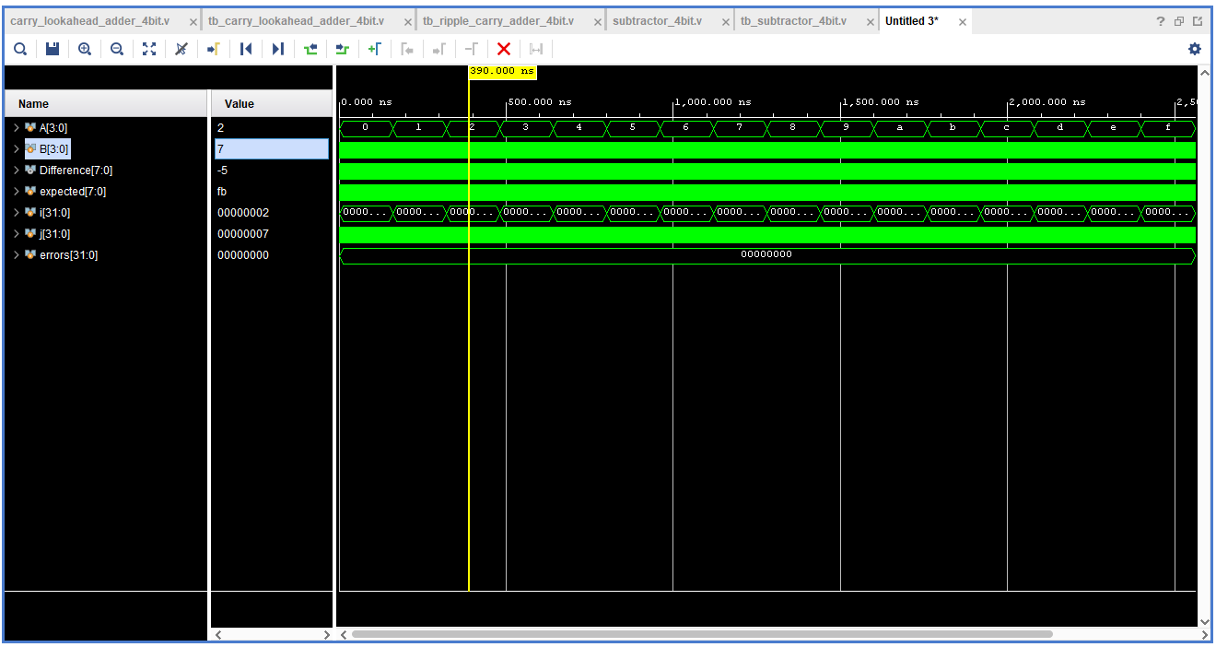Example test case:
- A = 2
- B = 7
- Expected result = −5
- Difference = 8'b11111011 (0xFB)
- Errors = 0
The waveform confirms that negative results are correctly represented using 8-bit two's-complement notation.

6. Synthesized Schematic
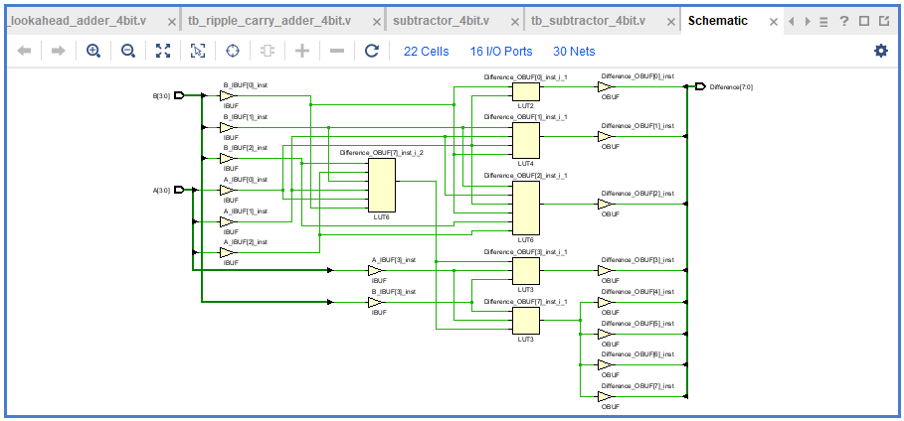Synthesis summary:
Parameter | Result
Total cells | 22
I/O ports | 16
Nets | 30
LUT count | 6

7. LUT INIT Values
The following LUT INIT values were obtained from the Vivado Tcl Console after synthesis:
Difference_OBUF[0]_inst_i_1 : 4'h6
Difference_OBUF[1]_inst_i_1 : 16'h6966
Difference_OBUF[2]_inst_i_1 : 64'h2B22D4DDD4DD2B22
Difference_OBUF[3]_inst_i_1 : 8'h96
Difference_OBUF[7]_inst_i_1 : 8'hB2
Difference_OBUF[7]_inst_i_2 : 64'h22B2B2BB22B222B2
Total LUTs = 6

